LESSON 2 A2+ TUESDAY 9TH

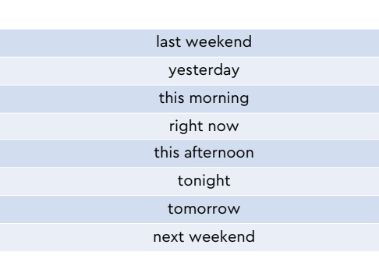

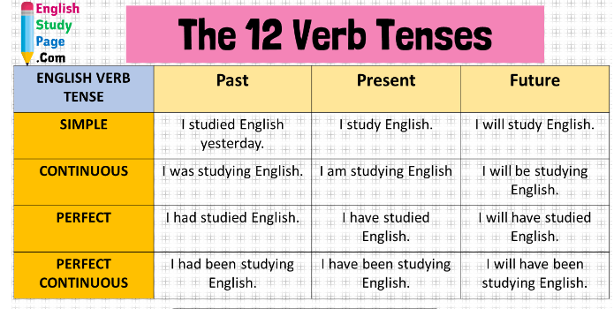

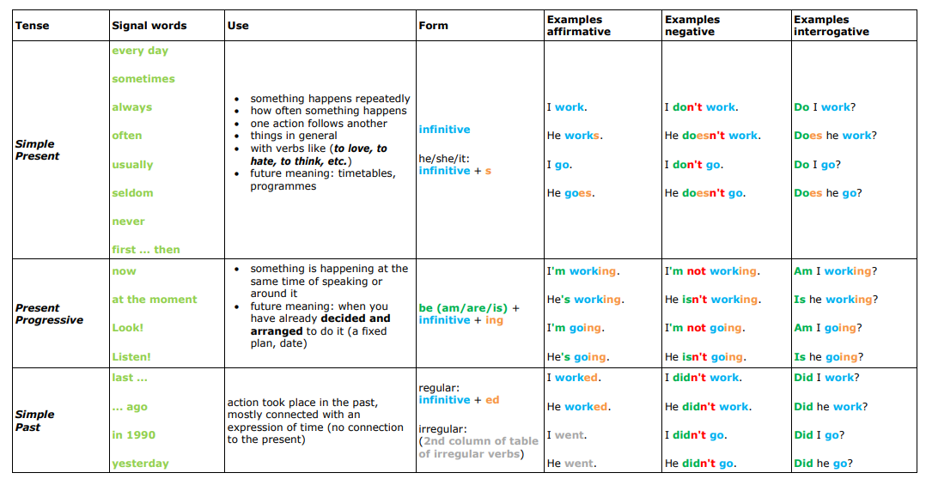

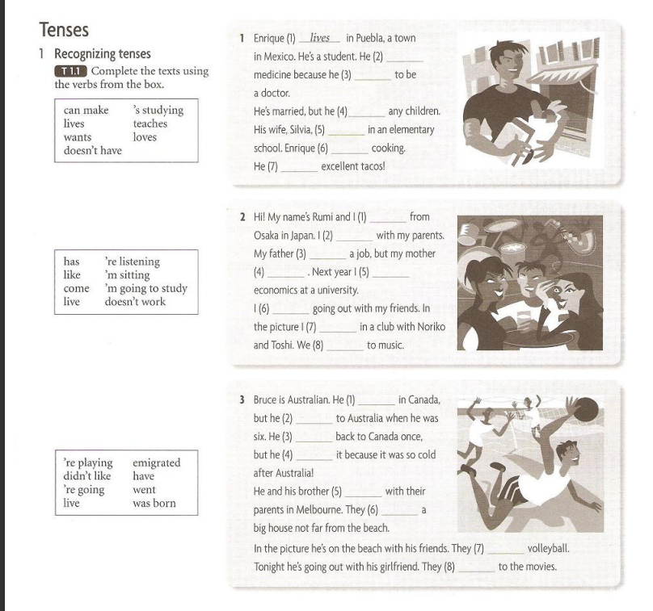

1. 2- `s studying. 3) wants 4) doesn`t have 5) teaches 6) loves 7) can make
2. 1-come 2-live 3-has 4-doesn’t work 5- I`m going to study 6- like 7- `m sitting 8- `re listening.
3. 1- was born 2. Emigrated 3- went 4- didn`t like 5- live 6 -have 7- `` re playing 8-`re going

What is one thing that you did last weekend? Last weekend I watched a movie, called Pour things.

What is one thing that you did yesterday? Yesterday I went to the gym and I took my gym class

What did you do this morning? This morning I had a great breakfast .

What are you doing right now? I am studying English.

What are you going to do this afternoon? This afternoon I am going to the cinema.

What are you going to do tonight? What are you going to do tomorrow? Tonight, I am going to read a book , and tomorrow I am going to work.

What are you going to do next weekend? I am going to ride a bike,

What are you going to do the day after tomorrow? I am going to take my tennis class.

What are you going to do in three days? In three days I am going to go to the doctor.

What did you do the day before yesterday? Before yesterday I had a dinner with some friends

What did you do three days ago? Three days ago, I met with my new boss.

What did you do last week? The last week I worked at home.

What are you going to do next week? The next week I am going to work at the office.

Ask them about their weekends. What did they do last weekend? What are they going to do next weekend? What do

they like to do on weekends ?

What did you do last weekend? What did you yesterday? What time did you woke up yesterday? What did you do this morning?

What are you going to do tomorrow? What are you going to go tonight? What are you going to do next week? What time are you going to leave home tomorrow? What time are you going to come home tomorrow?

What do you like to do on week? What do you like to eat on weekend? What do you like to wear to work? What do you like to listen ? what do you like to have for breakfast? What do you like to have for dinner?

**EXERCISE 1:**

1. I ___do__ _______________(do) many things every day.
2. She _ __is cooking__________________(cook) pizza at the moment.
3. They _had_____ ________________(have) a party last Sunday.
4. We _ __are going to do____________(do) it tomorrow.
5. She ___wrote___ ______________(write) this exercise 2 weeks ago.
6. He usually ___ ___buys_________________(buy) modern clothes.
7. Look! The children __ are playing___________________(play) with snowballs.
8. They ____wrote___ ____________(write) a quick-test yesterday.
9. They sometimes ______break______________(break) their toys.
10. The boy ____got______________________(get) only good marks last year.

**EXERCISE 2**

1. Listen! Somebody __are shouting_______________________(shout).

2. We often ____go___________________(go) to school by bus.

3. They ___bought ________________________(buy) their car in 2010.

4.I _____am waiting__________________(wait) for the teacher now.

5. My granny ____________is going to visit_____________(visit) us next week.

6. They _______rest___________________(rest) on the beach every summer.

7. I _________am coloring_____________(color) the picture right now.

8. They _______cooked__________________(cook) a tasty meal last week.

9. I always ________drink________________(drink) tea in the morning.

10. They ____________will work / are going to work_________________(work) harder next year.

**EXERCISE 3**

1. The teacher ______is marking_____________________(mark) our tests at the moment.

2. People occasionally _____has____________________(have) massage.

3. We _______________rested_________(rest) in the mountains last winter.

4. Look! Somebody _______is waiting_______________(wait) for you.

5. She _______travels___________(travel) abroad in summers.

6. We _________ are going to go____________(go) on an excursion abroad next spring.

7. They ____saw_______________(see) that film 3 days ago.

8. Listen! Mary ____is playing______________(play) the piano.

9. My mother ________takes_____________(take) the dog out every morning.

10. They ______ will go______________(go) abroad in 2030.

GOING TO:

* PLANS/INTENTIONS/DECISIONS (PLANNED)
* PREDICTIONS (BASED ON PRESENT EVIDENCE)

WILL

* INTENTIONS/ DECISIONS (AT THE MOMENT OF SPEAKING)
* PREDICTIONS: IN THE YEAR 2300/// I THINK…. /I´M NOT SURE

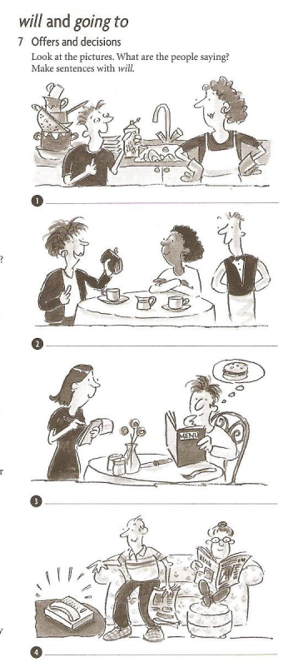

1. I will wash the dishes.
2. I will pay the bill
3. He will order a hamburger. I^ll have a
4. 4-I will attend the telephone. I`ll answer

2.- Books are going to fall on his head 3- she is going to teach 4- the cat is going to attack the bird 5-he is going to make a bookshelf 6- They are going to plant a tree 7- he is going to fall into the well

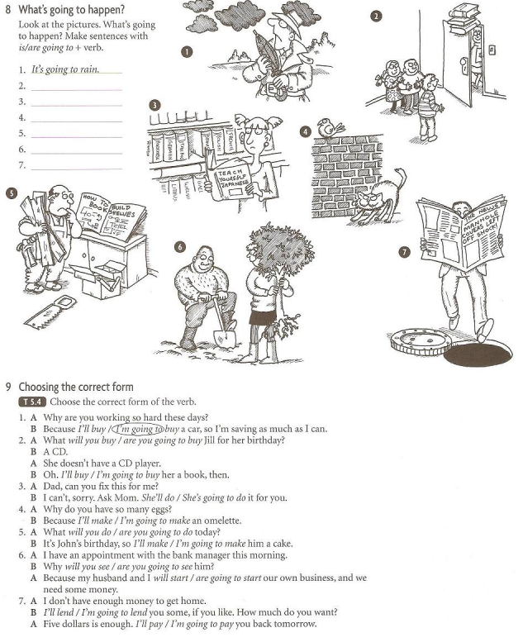

2- What will you buy jill for her birthday?

3-She is going to do for you.

4-because I ´m going to make him a cake.

5-what will you do?

6-why will you see ?? my husband and I are going to start our own bussnes

7-I¨ll lend… / I´m going to pay back tomorrow

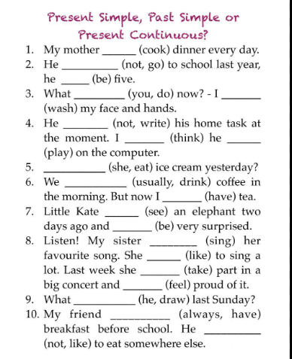

1. Cooks 2- didn`t go / was. 3- what are you doing now? I am washing my face and hands. 4 he isn`t writing / I think he is playing

5 Did she eat ice cream? 6- we usually drink coffee. 7.- saw / was 8- MY SISTER is singing / she likes / she took part … and felt.. 9- what did he draw las Sunday? 10- always has breakfast….. He doesn`t like

**Mixed tenses here!!!**

[**https://www.liveworksheets.com/w/en/english-second-language-esl/51738**](https://www.liveworksheets.com/w/en/english-second-language-esl/51738)

[**https://www.liveworksheets.com/w/en/english-second-language-esl/54983**](https://www.liveworksheets.com/w/en/english-second-language-esl/54983)

[**https://www.liveworksheets.com/w/en/english-second-language-esl/57315**](https://www.liveworksheets.com/w/en/english-second-language-esl/57315)

**NOUNS AND PRONOUNS:**

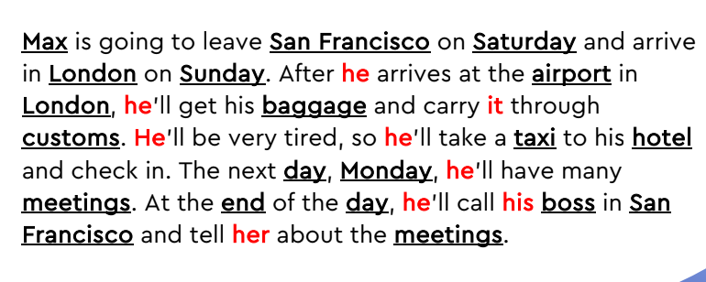

**Main Activity 2: Likes and Abilities**

I am going to read a sentence. Tell me the number of the picture. Have the class answer, or different students.

He’s cooking. 6

They’re playing volleyball. 9

He’s riding a bike. 5

She’s drawing. 4

They are dancing. 1

He’s reading a book. 2

They’re going to a movie. 9

She’s growing flowers. 7

They’re playing music. 3

They can dance very well. 1

He enjoys riding his bike. 5

They are good at playing volleyball 9

He loves to read, especially novels. 2

He knows how to cook. [6]

He enjoys playing the violin. [3]

On weekends, they enjoy going to the movies with friends. 8

She knows how to draw and paint. 4

She is good at growing flowers. 7

They know how to play volleyball. 9

He enjoys cooking. 6

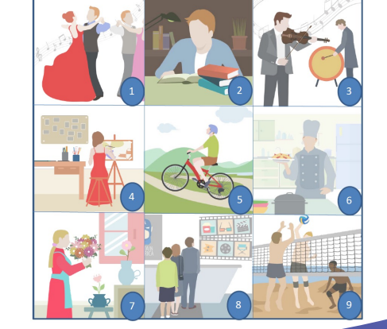

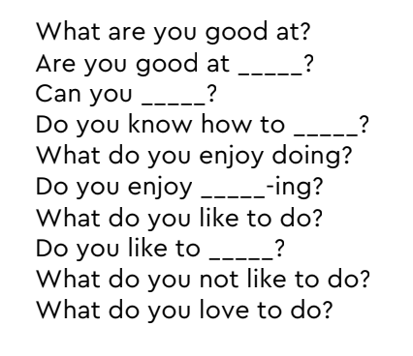

What are you good at? I am good at playing tennis. I am good at making ice cake

Are you good at __cooking___? No I am not good at cooking

Can you __spell you name___? Yes I can spell mi name. Can you play golf? No I can,t I don´t know how to play golf.

Do you know how to _paint? No I don´t know how to paint. Do you Know how to play tennis? Yes I do.

What do you enjoy doing? I enjoy watching movies with my daughter . I enjoy playing tennis

Do you enjoy _____study-ing? Yes I do. I love to study. Do you enjoy riding a bike ? No I don’t enjoy.

What do you like to do? I like to go to cinema. I like to play tennis, I like to watch series.

Do you like to _ride a bike____? No I don’t like. Do you like to wake up early? No I don’t like.

What do you not like to do? I don’t like to work in the office. I don´t like to sleep a nap.

What do you love to do? I love to eat chocolate. I love to listen to music.

**Main Activity 3: Motion and Force**

. 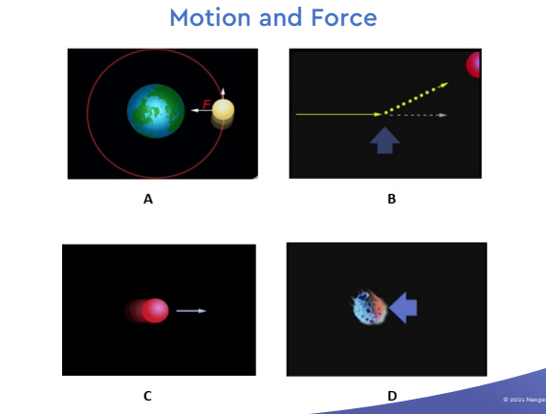

A. In picture A, we see the Earth and the Moon. The “F” stands for force. The force that keeps the Moon revolving around the Earth is gravity.

B. In picture B, we see a red ball that was moving from left to right. Then, it was hit by a force from the bottom of the picture. That force changed the direction of the red ball. Now it is going to the left.

C. In picture C, we see a red ball that is NOT changed by a force. It keeps moving in the same direction at the same speed.

D. In picture D, we see a force hit an object from the front. This changes the speed of the object. The object is now moving more slowly.

**Write down which picture goes with my sentence.**

1. A force can change the direction of a moving object. (B)

2. A force can change the speed of an object. (D)

3. Without a force, an object’s direction and speed will stay the same. (C)

4. The Moon moves around the Earth in a circular orbit because of the force of gravity. (A)

A.

• The Moon goes around the Eart

• The Moon has a circular orbit around the Earth.

• The force of gravity makes the Moon go around the Earth.

• Gravity changes the direction of the Moon.

B.

• A force can change the direction of a moving object.

• The force shown by the arrow changes the path of the moving object.

• Without a force, the object would continue to go in a straight line.

C.

• An object in motion has a direction and it has a speed.

• A moving object will continue in the same direction and at the same speed unless it is acted on by a force.

• If there are no other forces, the speed and direction of the moving object do not change.

D.

• A force can change the speed of a moving object.

• The force can make the object slow down or go faster.

• In this picture, the force will make the object slow down or stop.